Development Tools Assignment

Module 2 – Network Performance Measurement Tools

1. Install Wireshark, take capture on WiFi interface
2. Identify the beacon frame using filter.

Answer:

To capture beacon frames “wlan.fc.type_subtype == 0x08” is the filter type.

beacons are part of the management frames which has the type field set to 0 and beacons are represented by a hex value of 0x8.

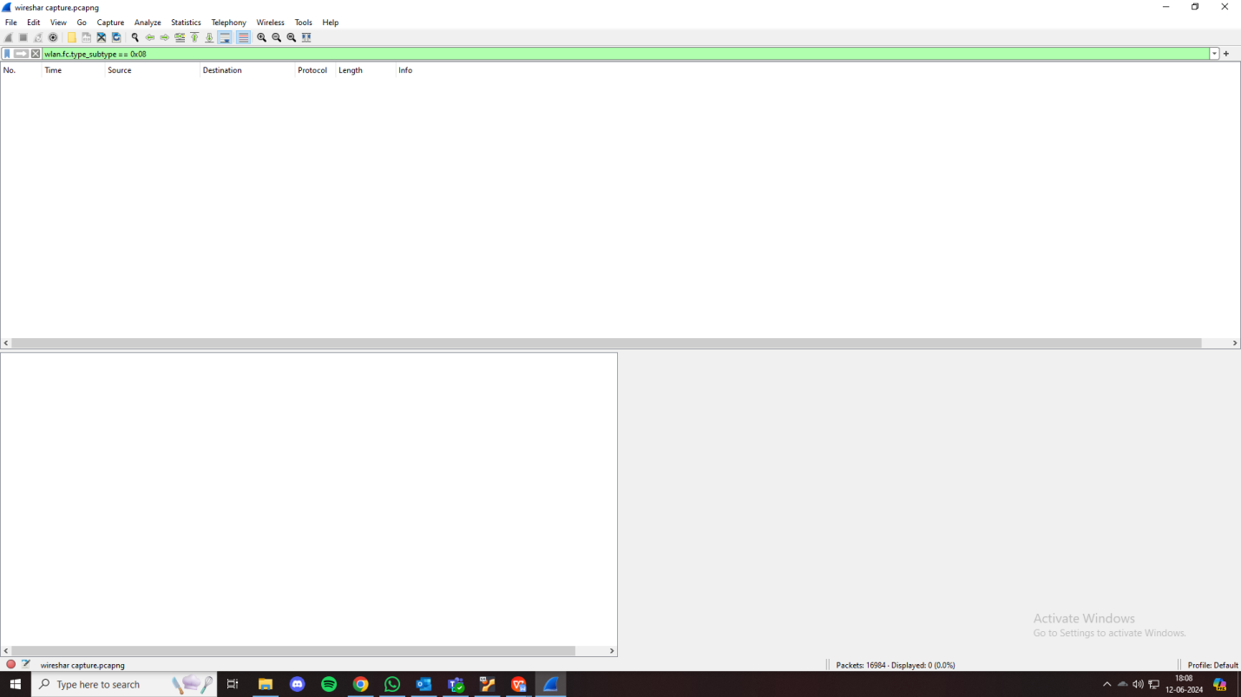

(there are no beacon frames because I don’t have wifi moniter mode support).

1. Apply filters to view specific packet.

Answer:

Type “tcp” in filter to view only tcp protocol packets

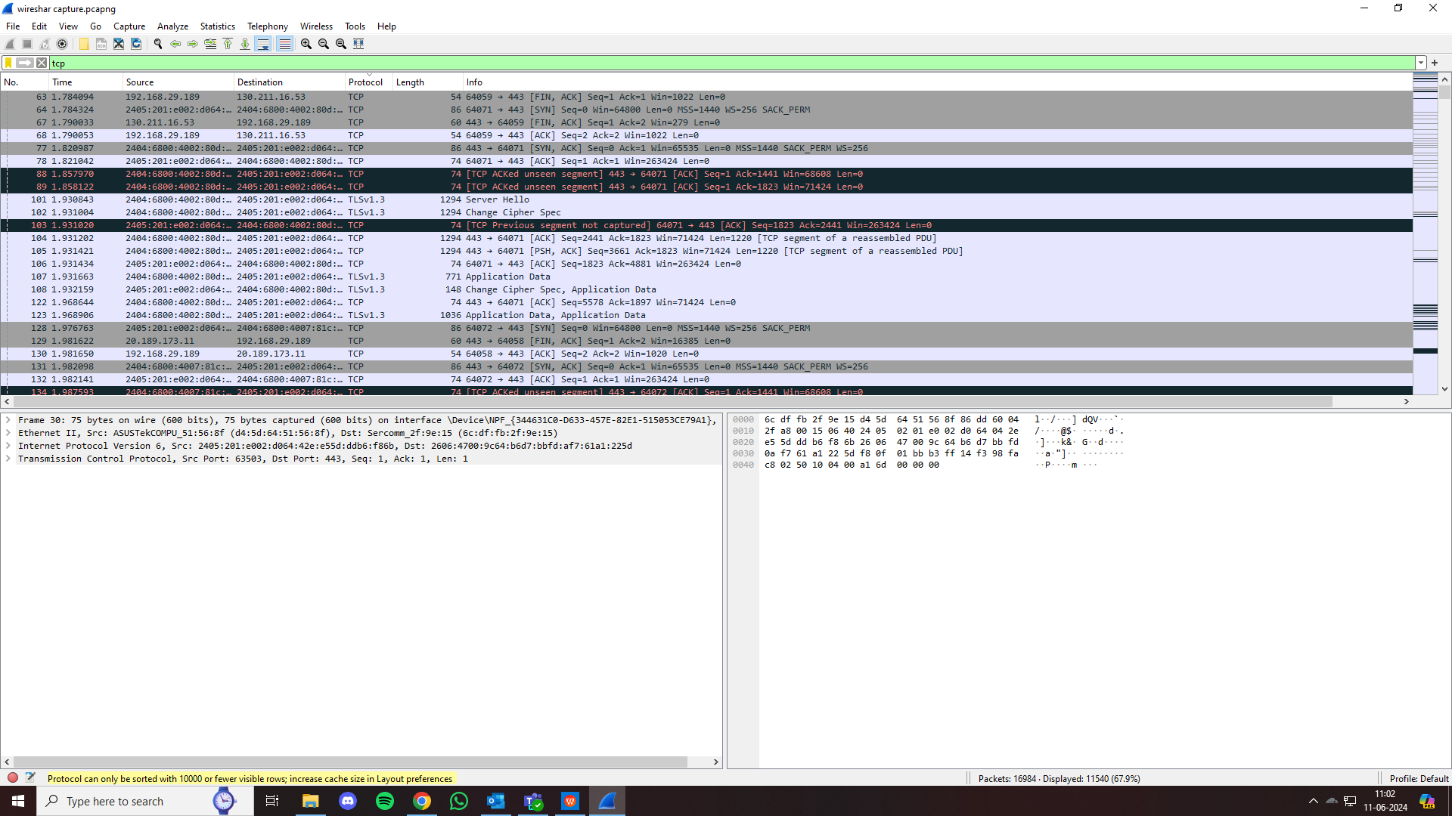

Type “udp” in filter to view only udp protocol packets

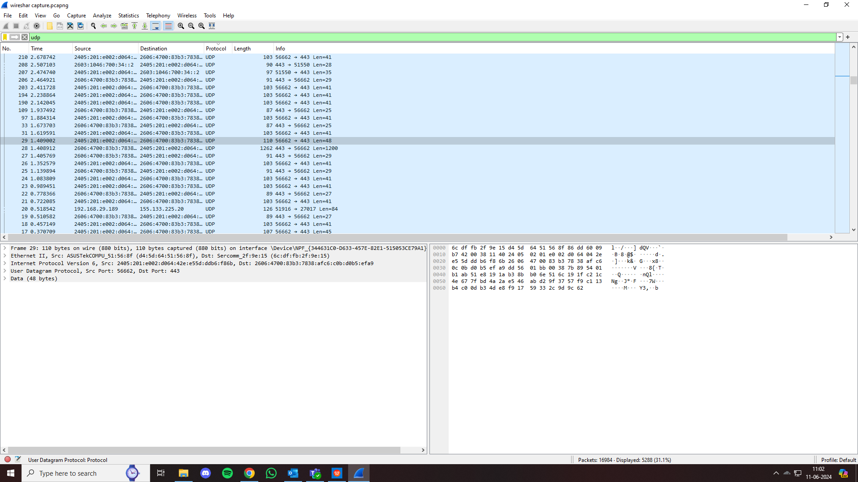

1. Decrypt the wireshark pcap using passphrase, to view the encrytped packets.

Answer:

The passphrase is the password of the WiFi Router.

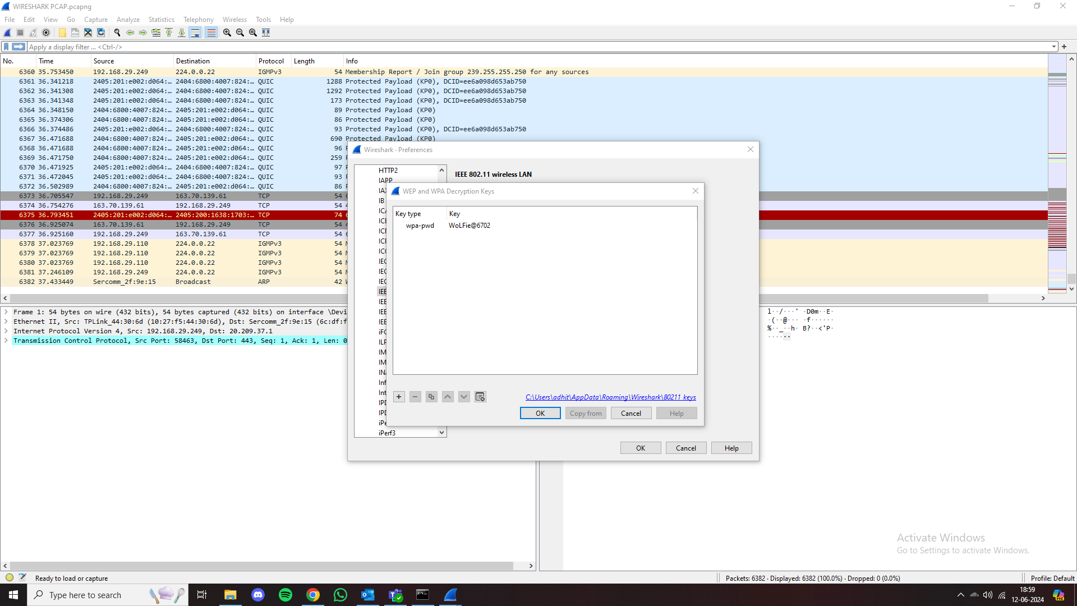

1. Point out ethernet and 802.11 frames.

Answer:

Type “eth” in filter to show only frames sent/received over ethernet.

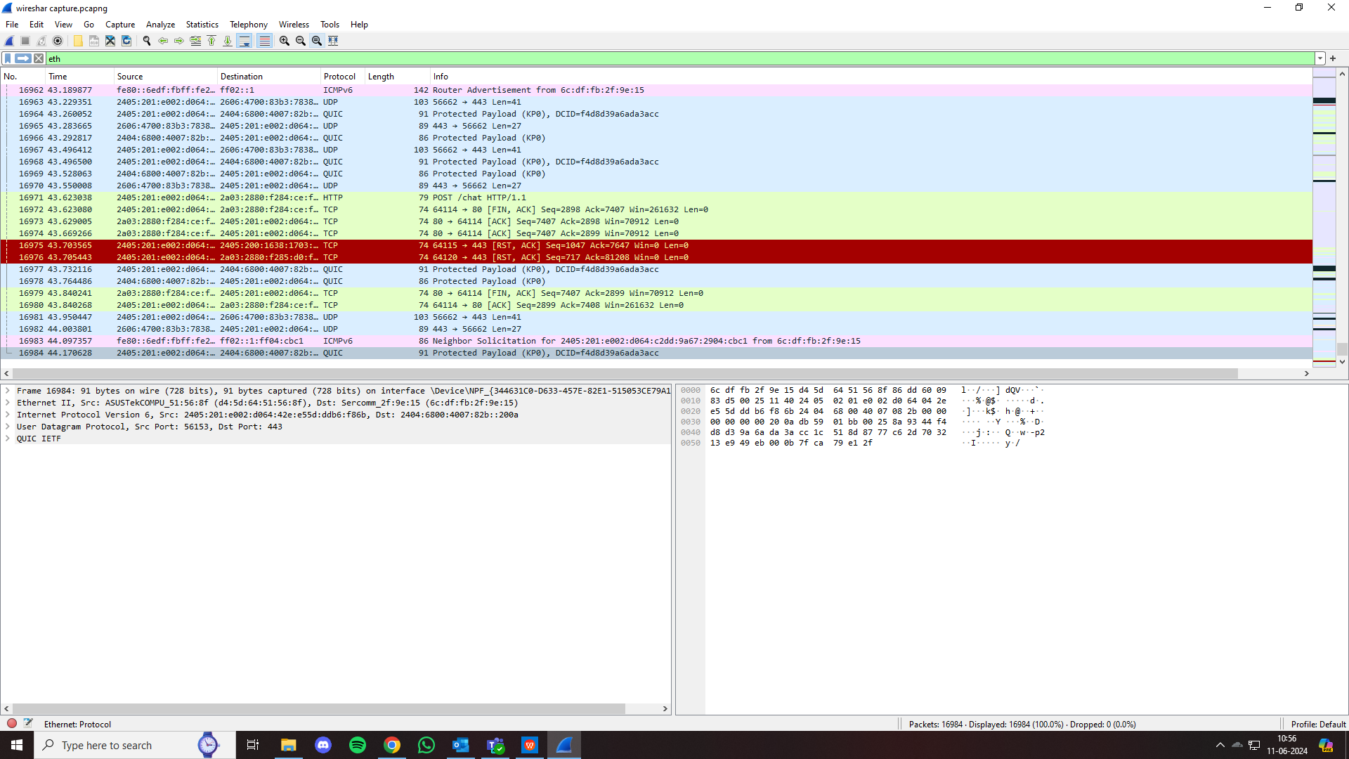

Type “wlan” in filter to show only 802.11 frames.

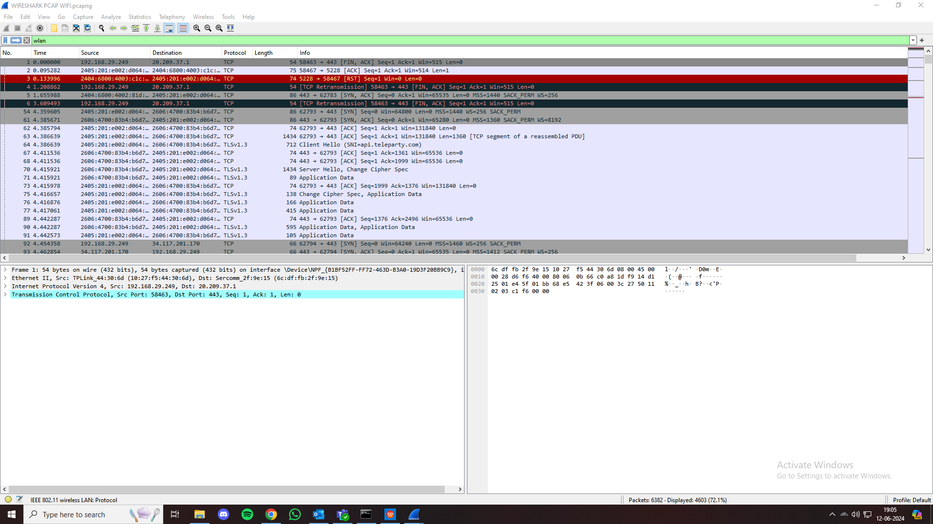

2) Install Iperf on client and server device

1. Run TCP traffic

> client side: iperf3 -c <ip-address>

> server side: iperf3 -s

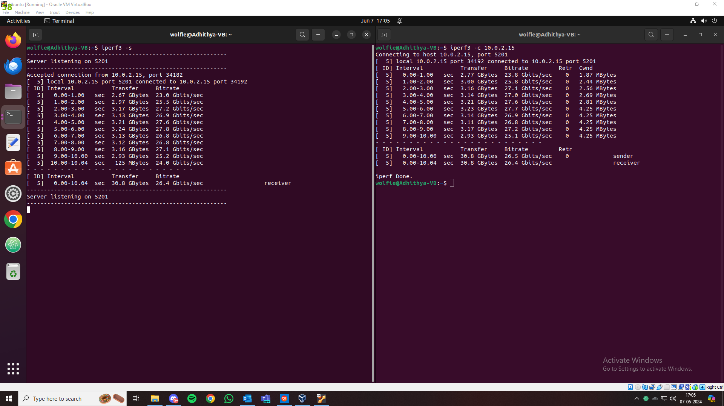

Average Transfer rate : 32.0 GBytes

Average Bitrate : 26.4 Gbits/sec

1. Run UDP traffic

> client side: iperf3 -c <ip-address> -u

> server side: iperf3 -s

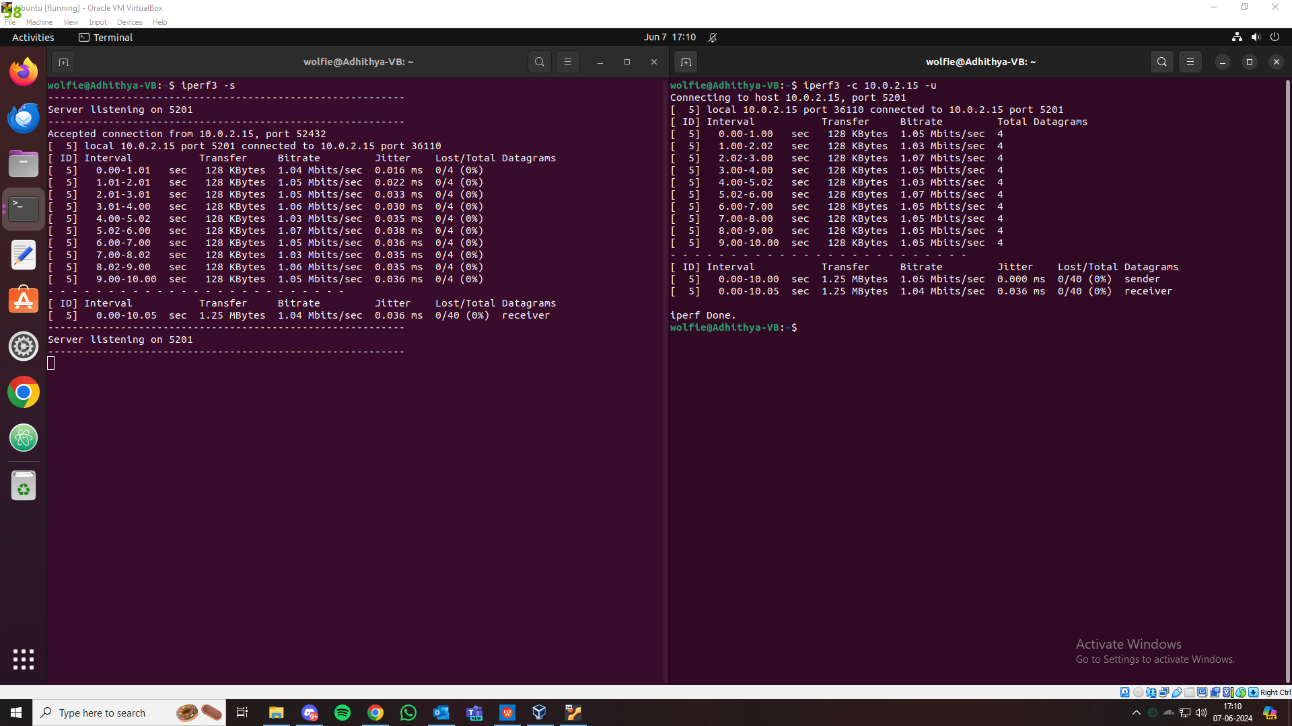

Average Transfer rate : 1.25 Mbytes

Average Bitrate : 1.04 Mbits/sec

Jitter : 0.036 ms

Lost/total Datagrams : 0/40 (0%)